**DAILY ONLINE ACTIVITIES SUMMARY**

|  |  |  |  |  |  |  |  |  |
| --- | --- | --- | --- | --- | --- | --- | --- | --- |
| **Date:** | **23-05-2020** | | | | | **Name:** | **Ashwini S Jadamali** | |
| **Sem & Sec** | **6th Asec** | | | | | **USN:** | **4AL17CS018** | |
| **Online Test Summary** | | | | | | | | |
| **Subject** | | **Python Application Programming.** | | | | | | |
| **Max. Marks** | | **30** | | **Score** | | | **17** | |
| **Certification Course Summary** | | | | | | | | |
| **Course** | **INTRODUCTION TO ETHICAL HACKING** | | | | | | | |
| **Certificate Provider** | | | Greatlearning  Academy | | **Duration** | | | 9hours |
| **Coding Challenges** | | | | | | | | |
| **Problem Statement:** 1. Write a C Program to Generate First N Triangular Numbers (Where N is read from the Keyboard) | | | | | | | | |
| **Status: Done** | | | | | | | | |
| **Uploaded the report in Github** | | | | | **YES** | | | |
| **If yes Repository name** | | | | | **https://github.com/ashwinijadamali/online-coding-activites** | | | |
| **Uploaded the report in slack** | | | | | **YES** | | | |

Online Test Details:

Subject:-Python Application Programming.

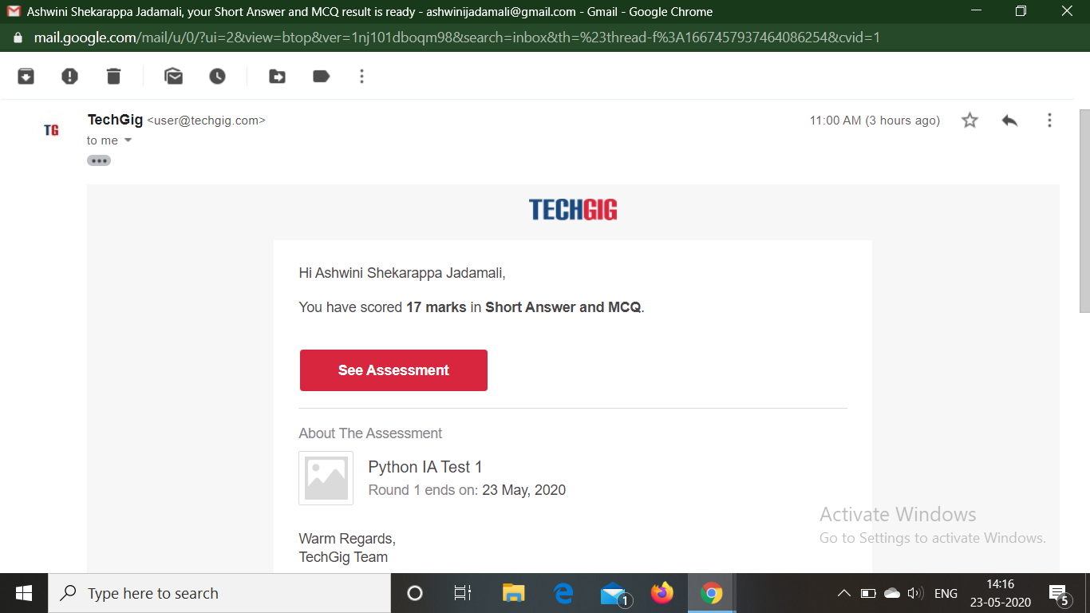

Certification Course Details:

**Introduction to Ethical Hacking:**

Today I have studied **What** **Ethical Hacking:**

Under this topic I have studied:-

* Introduction to Ethical Hacking.

* Computer Security Threats.

* Goals, Skills and Tools Utilized.

* Process Flow for an Ethical Hack.

* Ethical Hacking across Domains.

* Maintaining Access.

* Reconnaissance.

* Goals of Ethical Hacking.

* Computer Security Threat.

* Clearing Tracks.

* Skills required by Ethical Hackers.

* Scanning.

* Demonstration on:

1. Scan a business to figure out the servers.

2. Scan a server to figure out open ports.

3. Scan the ports to figure out the services.

4. Exploits the server using Hydra.



Coding Challenges Details:

1.Write a C Program to Generate First N Triangular Numbers (Where N is read from the Keyboard)

#include <stdio.h>

void triangular_series(int n)

{

int i, j = 1, k = 1;

for (i = 1; i <= n; i++) {

printf(" %d ", k);

j = j + 1;

k = k + j;

}

}

int main()

{

int n ;

printf("enter n");

scanf("%d",&n);

triangular_series(n);

return 0;

}

**OUTPUT:**

